Using the Canon EOS Rebel G
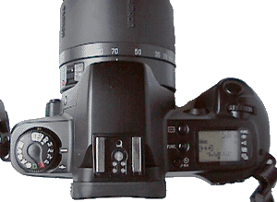  The Canon EOS Rebel G is the low-cost member of the Canon EOS line. Still, it has many features in common with top-line cameras, and it offers full manual control. It's small size, light weight, and low cost make it the ideal camera to use as a back-up, to backpack in to a remote location, or to carry into a situation where you don't want to risk a more expensive camera. The Rebel G has been replaced by the Rebel 2000, which is very similar. |  |  | 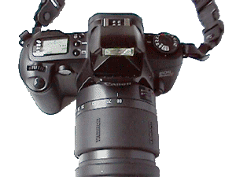
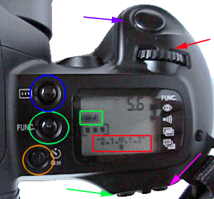 |  |  | 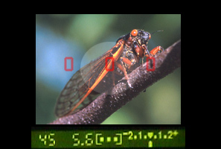
Top | Loading Film | Changing Lenses |  | Choosing an Exposure Mode | Taking a Picture
Focusing Point Selection | Self Timer | Exposure Compensation |  | Partial Metering/AE Lock | Autoexposure Bracketing
Red-eye Reduction | Beeper | Multiple Exposures |  | Flash | Mid-Roll Film Rewind

Basic Operation:

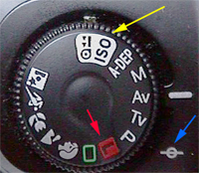  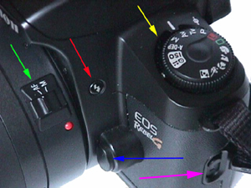  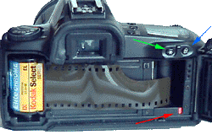 |  |  |  |  | Loading Film:  First, turn the camera on by rotating the control knob on the top left surface of the camera away from the "L" position (red arrow, top figure at left). Next, open the back of the camera by sliding the door latch on the left side of the camera (middle left image, purple arrow) UP. Place the film canister on the left side of the camera with the small plastic protrusion of the film canister over the orange film advance axle on the bottom left side of the camera. Stretch the film across the back of the camera until it reaches the orange mark at the bottom right (red arrow in the third figure to the left). Close the back of the camera.
  The film will be wound completely onto the take-up reel. As you take pictures, the film will be returned, frame-by-frame into the canister. This is advantageous as exposed frames are protected in the canister and will not be ruined if the camera is opened by mistake. Rewinding after the last frame is also very quick. On the other hand, it takes longer to load film. Finally, because of the way the film is loaded, it is very tricky to rewind a partial roll of film and use it at a later date in another camera.
  The film speed is automatically set and will be displayed in the LCD panel on the top right of the camera. To manually set the film speed, turn the control dial so that the ISO position (top left figure, yellow arrow) is at the white index mark (where the Av is in the figure). Next, turn the main control dial (bottom figure , red arrow) to the right or left until the proper film speed is displayed in the LCD panel.
Top | Loading Film |  | Changing Lenses |  |  |  | Choosing an Exposure Mode |  | Taking a Picture
Focusing Point Selection | Self Timer |  | Exposure Compensation |  |  |  | Partial Metering/AE Lock |  | Autoexposure Bracketing
Red-eye Reduction | Beeper |  | Multiple Exposures |  |  |  | Flash |  | Mid-Roll Film Rewind

Changing Lenses:
To change the lens, place the camera strap around your neck. Hold the camera facing away from you in your left hand, and use your index finger to press the lens release button (blue arrow, right). With your right hand, rotate the lens to the right (counterclockwise) so that the red dot on the lens moves up to the 12 o'clock position, where the lens will release. Cap the rear of the lens you have just removed with the cap from the lens you are mounting. Place the new lens with its red dot at the 12 o'clock position (there is another red dot on the lens mount to guide you) and twist it to the left about 30 degrees until it locks into place. Be sure the lens is firmly mounted before letting go. Be sure the lens that you removed is secured in your camera bag (and the bag is closed) before proceeding.
Top | Loading Film |  | Changing Lenses |  |  |  | Choosing an Exposure Mode |  | Taking a Picture
Focusing Point Selection | Self Timer |  | Exposure Compensation |  |  |  | Partial Metering/AE Lock |  | Autoexposure Bracketing
Red-eye Reduction | Beeper |  | Multiple Exposures |  |  |  | Flash |  | Mid-Roll Film Rewind

Choosing an Exposure Mode:
Exposure modes are chosen with the control dial on the top left side of the camera (left). In the illustration, the camera is set at the Av mode. The choices are:
P - the camera sets both aperture and shutter speed according to an internal program.
Tv - Shutter priority - you set the shutter speed and the camera selects the aperture.
Av - Aperture priority - you set the aperture and the camera sets the shutter speed.
M - Manual - you set both shutter speed and aperture; the camera's meter is available to guide you.
A-DEP - Automatic Depth of Field - The camera sets shutter speed and aperture to ensure that all three focusing points are in focus in the image.

There are 6 other exposure modes; these are all automatic and override all other camera settings:
Full Auto Mode (green square) - The camera automatically focuses on the nearest subject at a focusing point on the viewscreen. Shutter speed and aperture are set automatically. In dim light, the built-in flash is activated if needed.
Portrait Mode (head icon) - The camera sets both shutter speed and aperture, selecting a wide aperture to blur the background. In dim light, the built-in flash is activated if needed.
Landscape Mode (mountain icon) - The camera emphasizes depth of field with small apertures and slow shutter speeds. The flash is turned off.
Close-up Mode (flower icon) - Presumably, depth of filed is emphasized here, but the manual is sketchy on this point. The flash is activated if needed.
Sports Mode (runner icon) - Shutter speed is set as high as possible, and continuous advance film drive is turned on. The flash is turned off.
Night Scene Mode ( star and head icon) - Flash is used, along with a slow shutter speed.

Top | Loading Film |  | Changing Lenses |  |  |  | Choosing an Exposure Mode |  | Taking a Picture
Focusing Point Selection | Self Timer |  | Exposure Compensation |  |  |  | Partial Metering/AE Lock |  | Autoexposure Bracketing
Red-eye Reduction | Beeper |  | Multiple Exposures |  |  |  | Flash |  | Mid-Roll Film Rewind

Taking a Picture:  To take a picture (in one of the automatic modes), press the shutter button halfway (blue arrow, right). This will activate the autofocus (provided it is on) and the camera's meter. Look through the viewfinder, below. Put at least one of the focusing areas (they appear as gray rectangles which light up red when they are in focus) on the subject. When focus is achieved, press the shutter button completely.  About the viewfinder:  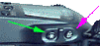  In the center of the viewfinder there is a circular area which delimits the partial metering area. There are also 3 rectangular focusing areas arrayed across the center of the viewfinder. At the bottom of the viewfinder is the shutter speed, the f-stop, the focusing point selection indicator, and the exposure meter. In the figure above, the shutter speed is 1/45 of a second, the f-stop is 5.6, the camera is set to select the focusing point automatically, and the exposure is dead on in the center of the meter. This information is also displayed in the LCD panel on top of the camera (above, right). |  |  | If you are not in an automatic mode, you will need to take additional steps before pressing the shutter button completely:  - If autofocus is not on, you will need to focus manually by turning the focusing knob on the lens until the subject is focused in the viewfinder.  - If you are in Tv or Av mode you will need to select the shutter speed (or aperture) by turning the main dial (red arrow, above) right or left to select the appropriate value. The camera will match your selection, if possible. A blinking number in the viewfinder means the camera cannot match your selection and you will need to make an adjustment.  - If you are in Manual Mode:  - When focus and exposure are set, take the picture.
  Turn the main dial (red arrow) to select the shutter speed.
  Press and hold the aperture button on the back of the camera (purple arrow, above) and left) with your thumb while turning the main dial to set the aperture.
  For "correct" exposure, make sure the exposure meter in the viewfinder (or in the LCD panel on top of the camera [red box, above]) is centered.
Top | Loading Film | Changing Lenses | Choosing an Exposure Mode | Taking a Picture
Focusing Point Selection | Self Timer | Exposure Compensation | Partial Metering/AE Lock | Autoexposure Bracketing
Red-eye Reduction | Beeper | Multiple Exposures | Flash | Mid-Roll Film Rewind

Advanced Features:
- Focusing Point Selection: Press and hold the selector button (blue circle, right) while turning the main dial (red arrow). You can select the left, middle, or right focusing point. The focusing point that is active is displayed in the LCD panel (between the green and red boxes) and in the viewfinder. If all three boxes are shown, the camera will select the focusing point automatically. Use this feature if your main subject is not in the center of the viewfinder.
- Self-timer: Press the self-timer button (orange circle). This will cause the timer icon to appear in the LCD panel. Look through the viewfinder, compose the picture by pressing the shutter button halfway and checking focus and exposure. Next press the shutter button all the way. The picture will be taken in 10 seconds. It can be canceled before this time by pressing the self-timer button again.
- Exposure compensation: You must be in the P, Tv or Av mode! Press the exposure compensation button (which is also the Av button - purple arrow above, right) and turn the main dial. You can adjust the exposure in 1/2 stop increments up to +/- 2 stops. The change is reflected in the exposure meter on the LCD panel (red box) and in the viewfinder. To the left is underexposure, to the right is overexposure. Exposure compensation is canceled in the manual mode and in all the icon modes.
- Partial Metering/AE lock: Normally the camera uses evaluative metering, which may fail if the background is particularly light or dark. Partial metering limits the exposure reading to the central circular area defined in the viewfinder. You can make a partial metering exposure by:
Focusing on the subject.
Pressing and holding the AE lock button on the back of the camera (green arrow, above).
Recomposing the picture (if you don't want the subject at the center.
Pressing the shutter button all the way down to take the picture.
- Autoexposure Bracketing: You must be in the P, Tv or Av mode! Press the function button (green circle, above) until the arrow at the right of the LCD panel points to the bottom of the four icons at the right of the screen. Rotate the main dial to the right. The exposure meter (red box) will gain two additional squares, with the new squares appearing to the right and left of the one in the center. Rotating the main dial additional clicks will spread the squares out. You can bracket 1/2, 1, 1.5 and 2 stops; the amount of bracketing is displayed in the LCD panel. Next take three pictures of the subject. The first will be normally exposed, the second will be underexposed, and the third will be overexposed by the amount you dialed in. To cancel this feature, follow the directions above, but turn the main dial to the left until the squares merge and the exposure bracketing reads 0.0.
- Red-eye reduction: To reduce red-eye when using flash, choose this function. Before the flash fires, a bright light on the camera will shine into the subject's eyes, momentarily blind them so that you can take their money. Actually, it closes down the irises of the subject's eyes, thus reducing red-eye, but it is pretty damn annoying. To turn this feature on, press the function button (green circle, above) until the arrow at the right of the LCD panel points to the top of the four icons at the right of the screen. Rotate the main dial to the right to turn it on (1) or left to turn it off (0). If the feature is on, a triangle will appear opposite the icon.
- Beeper: You can turn the beeper that sounds when focus is achieved on or off. Press the function button (green circle, above) until the arrow at the right of the LCD panel points to the second of the four icons at the right of the screen. Rotate the main dial to the right to turn it on (1) or left to turn it off (0). If the feature is on, a triangle will appear opposite the icon.
- Multiple Exposures: You can set the number of exposures that will be made before the film is advanced. Press the function button (green circle, above) until the arrow at the right of the LCD panel points to the third of the four icons at the right of the screen. Rotate the main dial to the right to increase or left to decrease the number of exposures from 1 to 9. If the feature is on, a triangle will appear opposite the icon, and the number of exposures to be taken on a single frame will be displayed numerically. Note that you will need to adjust the exposure or the resulting images will be too bright. As a general rule, use the exposure compensation and decrease it by 1 stop for 2 exposures, 1.5 stops for 3 exposures, and 2 stops for 4 exposures. Of course, you will have to experiment.
- Flash: In the icon modes, the built-in flash will pop up automatically if needed. In the P, Tv or Av modes, press the flash button (red arrow, right) to activate the flash. In these modes, the flash will try to supplement natural light. A blinking number in the viewfinder indicates that the background may be overexposed or underexposed. While the subject will probably be normally exposed under these circumstances, you may want to adjust the exposure settings until the blinking stops.
You cannot set a shutter speed faster than 1/90 of a second with the built-in flash.
You cannot use the built in flash with any unit attached to the hot shoe of the camera.
The subject must be at least 1 meter (3 feet) away.
With 100 speed film, the range of the flash is up to 12 feet (4 meters) with a wide angle lens, and 6 feet (2 meters) with an 80mm lens.
Be sure the lightning symbol appears in the viewfinder to the left of the shutter speed. This indicates the flash is charged and ready. You may have to wait between shots for the flash to recharge.
Use of the flash will drastically reduce battery life.
To use a Canon flash, simply mount it in the shoe.
Do not use non Canon EOS flash units. Although they may "fit" the electronics may not be compatible and you will damage the camera and the flash.

- Mid-roll film rewind: To rewind the film before you get to the end of the roll, set the control dial to rewind (just past the ISO setting, yellow arrow, right). Then press the self-timer/rewind button (orange circle, below right) for a second or until the film begins to rewind. Remember - the first exposure on the roll is the one furthest inside the film canister, and the unexposed film is at the beginning of the roll. If you have taken 10 shots (on a roll of 36) and rewind the film, in order to take the rest of the shots you must:
In the Rebel G: Insert the film canister. Let the camera load the film, then cover the lens cap, turn off autoexposure, set the camera to manual with a shutter speed over 1/100 of a second, and advance the film 11 frames by pressing the shutter button. You can now take pictures normally.
In a camera which doesn't pull all of the film out of the canister and then rewind it as the exposures are taken: Load the other camera, and take pictures normally until frame number 26.

Top | Loading Film | Changing Lenses | Choosing an Exposure Mode | Taking a Picture
Focusing Point Selection | Self Timer | Exposure Compensation | Partial Metering/AE Lock | Autoexposure Bracketing
Red-eye Reduction | Beeper | Multiple Exposures | Flash | Mid-Roll Film Rewind

