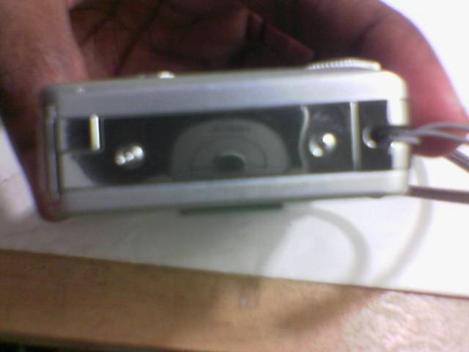
Remove
Remove
http://www.youtube.com/watch?v=f9Dxano3zcI

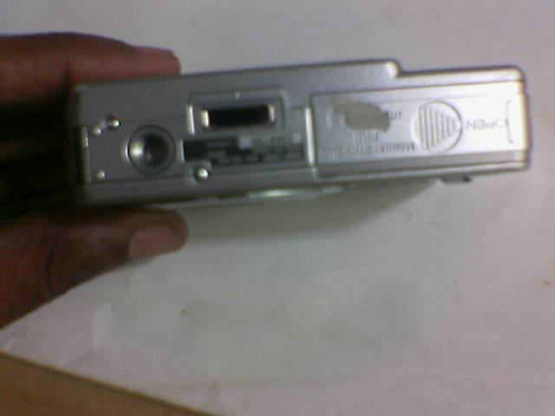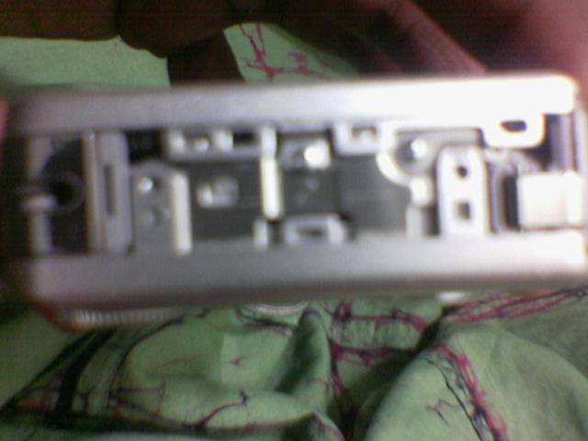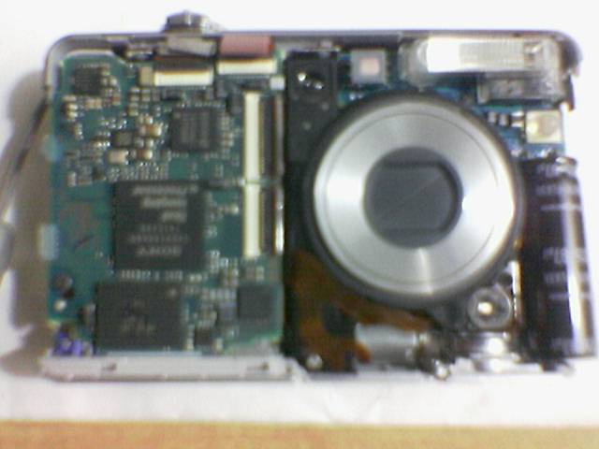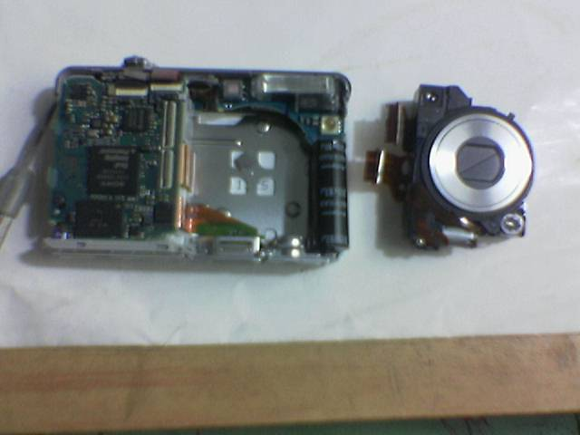
Remove
Remove
Drag this upward
Drag this upward

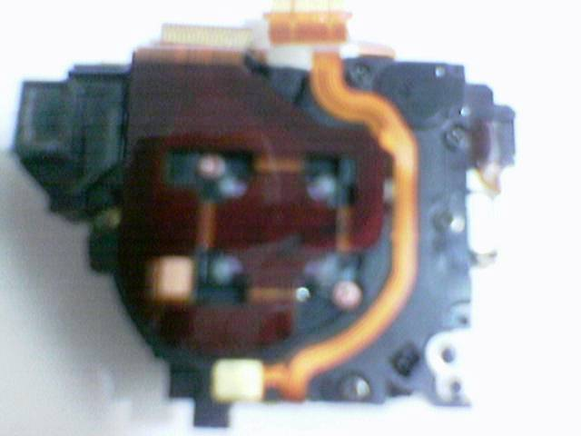
Remove
Remove
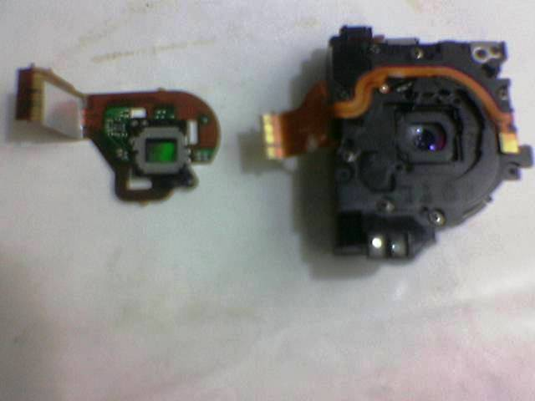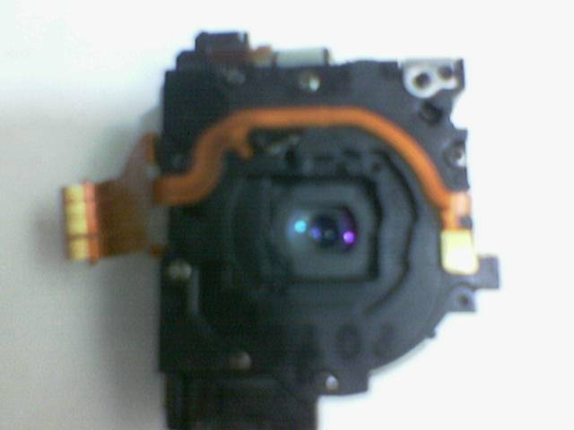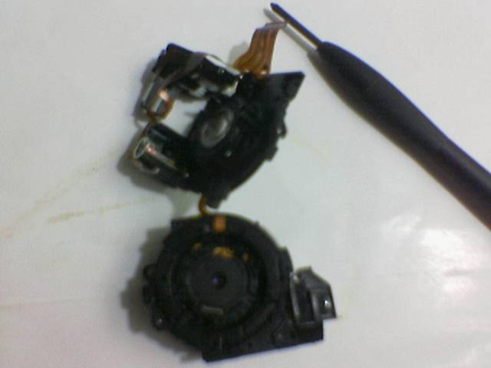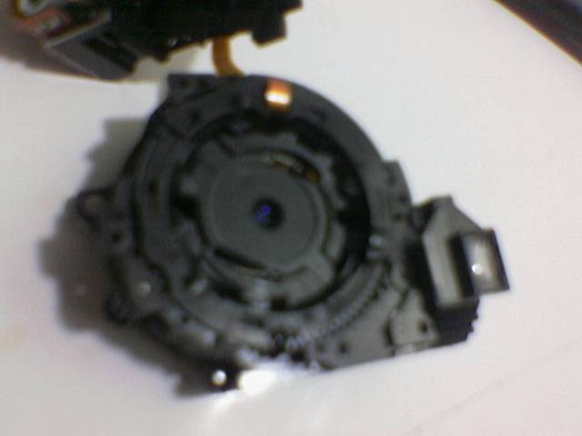
Handle with care 7.2 mpxl lens
Remove
Remove
Remove
Remove
Remove
Fix the spring
Fix the spring

Most of the time lens stuck due to dislocate of these tiny springs. Fix these springs carefully and reassemble the camera backwards.
Good luck…..
Send your comments to bopes_1@yahoo.com

